Order Of Service

Singing: Psalm 118—CW page 108

Reading: Psalm 119:89-96

Opening Hymn: CW 152

Reading: Romans 6:15-23

Request Hymn: CW Supplement 748

Reading: Matthew 16:21-28

Sermon Hymn: CW 147

Sermon Text: Mark 16:1-8

The Rising Of The Sun [Son]

Prayer

The Apostles’ Creed, TLH page 12

Holy Communion

The Lord's Prayer

The Blessing

Closing Hymn: CW 157

* * * * * * * * * * *

Koinonia Hour


Two Great Lights

Water
Of
Life

2 August 2020

W A T E R O F L I F E

Independent Christian Church—Conservative Lutheran Doctrine

Worship Service: 9:30 a.m. Bible Study: 10:45 a.m.

Larry Cooper, Pastor E-Mail address:
111 N. Ridge Road lcooper@wateroflife.cc
Coon Valley, WI 54623 Web Site:

* * * * * * * * * * * * * * * * * * * * * * * * * * *

Sermon Text: Mark 16:1-8

The Rising Of The Sun [Son]

* * * * * * * * * * * * * * * * * * * * * * * * * * *

Mark 16:1 And when the sabbath was past, Mary Magdalene, and Mary the mother of James, and Salome, had bought sweet spices, that they might come and anoint him.
:2 And very early in the morning the first day of the week, they came unto the sepulchre at the rising of the sun.
:3 And they said among themselves, Who shall roll us away the stone from the door of the sepulchre?
:4 And when they looked, they saw that the stone was rolled away: for it was very great.
:5 And entering into the sepulchre, they saw a young man sitting on the right side, clothed in a long white garment; and they were affrighted.
:6 And he saith unto them, Be not affrighted: Ye seek Jesus of Nazareth, which was crucified: he is risen; he is not here: behold the place where they laid him.
:7 But go your way, tell his disciples and Peter that he goeth before you into Galilee: there shall ye see him, as he said unto you.
:8 And they went out quickly, and fled from the sepulchre; for they trembled and were amazed: neither said they any thing to any man; for they were afraid.

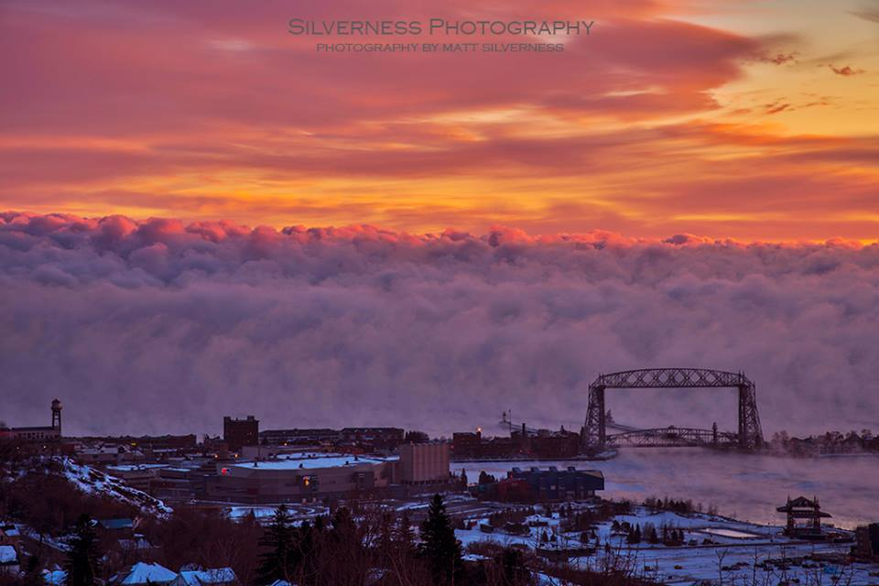

Sunrise In Duluth, MN

